Comprehensive Audit and Analysis for Effective Digital Presence

Zoho Corporation Pvt. Ltd.


TABLE OF CONTENTS
- Company Profile
- Website Audit Report
- Digital Marketing Strategy
- Landing Page Design
- Conclusion
- References

PROJECT OBJECTIVE
The objective of this project is to evaluate Zoho Corporation's digital presence by conducting a comprehensive website audit, analyzing its digital marketing strategies, and designing an effective landing page to improve user engagement, lead generation, and brand visibility.

INTRODUCTION
In today's competitive digital environment, an effective online presence is essential for business growth. This project evaluates Zoho Corporation's website, analyzes its marketing strategies, and identifies opportunities to improve digital performance and customer engagement.

Particulars | Details
Company Name
  Zoho Corporation Pvt. Ltd.
Industry | Software as a Service (SaaS)
Founded | 1996
Headquarters | Chennai, Tamil Nadu, India
Founders | Sridhar Vembu & Tony Thomas
Products
  CRM, Books, Mail, Projects, People, Desk, Creator and more
Website
  www.zoho.com

OVERVIEW
Zoho Corporation Pvt. Ltd. is a leading provider of cloud-based business software that helps organizations streamline their operations through a single integrated platform. Its solutions enable businesses to improve productivity, collaboration, and customer management while supporting digital transformation with secure and user-friendly applications and manage everyday processes effectively, making it a trusted technology partner for businesses worldwide.
MISSION
To provide powerful, affordable, and privacy-focused cloud software that enables businesses of all sizes to improve productivity and achieve sustainable growth.

VISION
To empower businesses worldwide with innovative technology solutions that simplify operations and drive digital transformation

Why I Selected ZOHO
- One of India's leading SaaS companies.
- Strong global digital presence.
- Professional and user-friendly website.
- Excellent SEO and digital marketing practices.
- Ideal for website audit and landing page analysis.

WEBSITE AUDIT REPORT
Website Audit Summary
The Zoho website was evaluated based on website design, user experience (UX), performance, accessibility, SEO, and overall functionality. The audit included both manual observation and Google PageSpeed Insights analysis for mobile and desktop versions. Overall, the website demonstrates a strong digital presence with an intuitive interface, excellent accessibility, and well-implemented SEO practices. However, performance optimization can further enhance the user experience, especially on mobile devices.
1. Website Design
Zoho's website features a clean, modern, and professional design that reflects the company's brand identity. The homepage effectively showcases important products through the Featured Apps section and highlights the Zia Agent platform with a visually engaging hero banner. The consistent color scheme, typography, and high-quality visuals contribute to a positive first impression and improve overall usability.
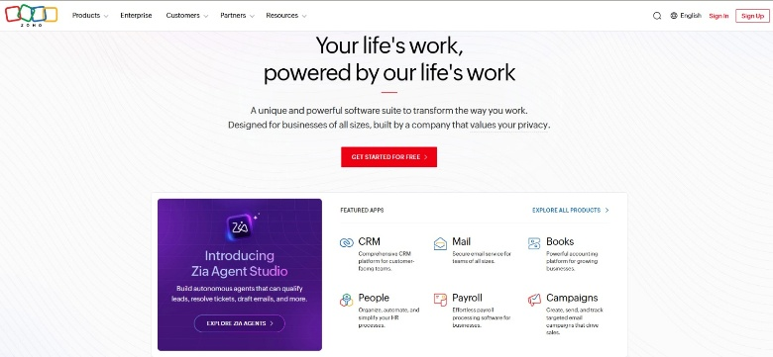
Figure: Zoho Homepage showing Featured Apps, Zia Agent, and the "Get Started for Free" call-to-action.

2. User Experience (UX)
The website provides an intuitive and user-friendly experience. The navigation menu is well organized, allowing users to easily access products, services, pricing, and support resources. Information is logically structured, making it simple for visitors to find relevant content. The "Get Started for Free" call-to-action button is prominently displayed, encouraging visitors to explore Zoho's services and increasing the likelihood of lead generation.

3. Performance Analysis
The website was tested using Google PageSpeed Insights.
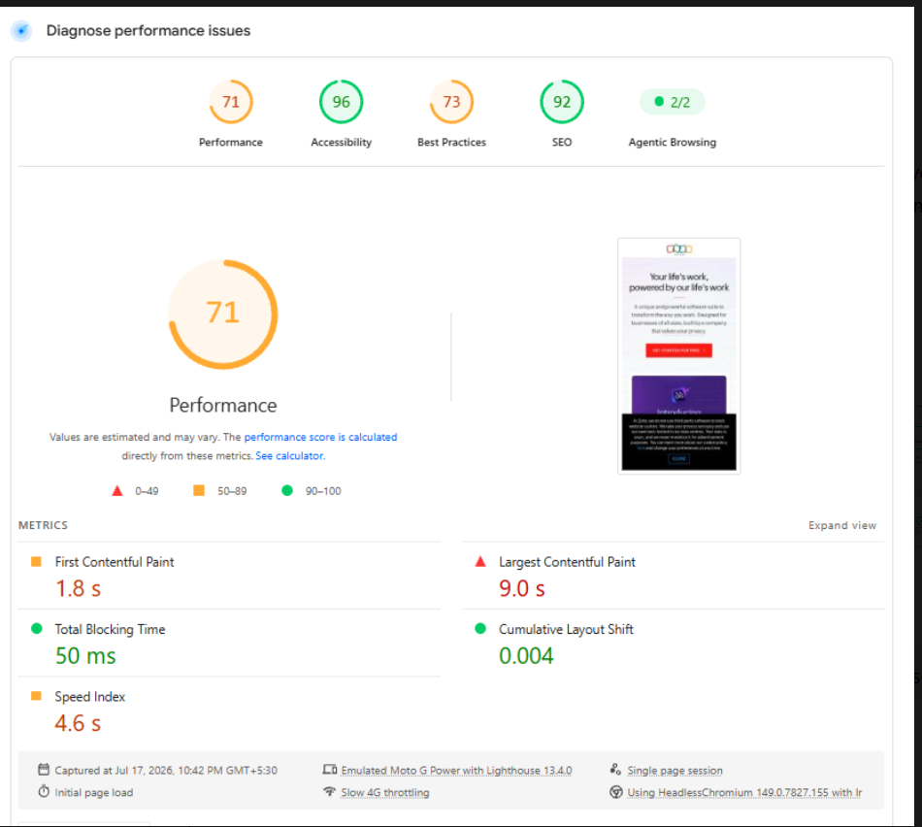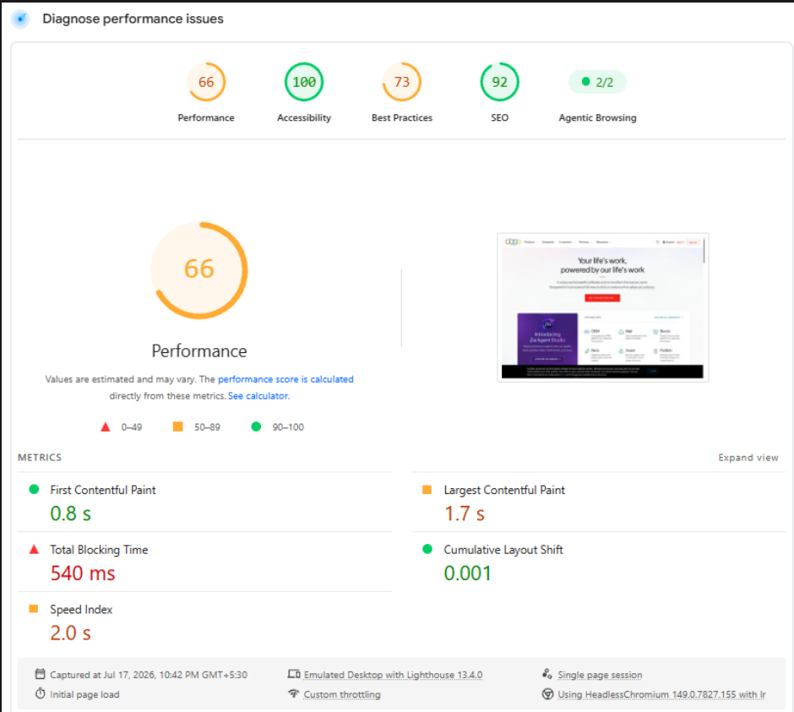
Figure: Google PageSpeed Insights – Mobile Performance Analysis Figure: Google PageSpeed Insights – Desktop Performance Analysis
Mobile Performance | Desktop Performance
  Metric | Score
  Performance | 71
  Accessibility | 96
  Best Practices | 73
  SEO | 92
  Metric | Score
  Performance | 66
  Accessibility | 100
  Best Practices | 73
  SEO | 92
The PageSpeed Insights audit shows that Zoho achieves excellent scores in Accessibility and SEO, demonstrating compliance with usability and search engine optimization best practices. While the overall performance score is moderate, the website provides a stable browsing experience. The Desktop Core Web Vitals assessment passed successfully, whereas the Mobile Core Web Vitals assessment indicates scope for further performance optimization, particularly in page loading speed and responsiveness.
4. SEO Analysis
The website follows several SEO best practices that contribute to its strong search engine performance. It uses optimized page titles, relevant meta descriptions, proper heading hierarchy, and SEO-friendly URLs. With an SEO score of 92/100, the website is well positioned for search engine visibility and organic traffic.
5. Strengths
- Modern and professional website design.
- Excellent Accessibility score (96–100).
- Strong SEO implementation (92).
- User-friendly navigation and logical content structure.
- Clear and effective "Get Started for Free" call-to-action.
- Responsive design across different devices.

6. Areas for Improvement
- Improve website performance on both mobile and desktop.
- Optimize images to reduce loading time.
- Reduce unused CSS and JavaScript.
- Minimize render-blocking resources.
- Address browser console errors and optimize third-party scripts.
7. Conclusion
The website audit concludes that Zoho Corporation has a strong and well-structured digital presence supported by excellent SEO, accessibility, and user experience. The website effectively communicates its products and services while providing visitors with an intuitive browsing experience. Although website performance can be further optimized, particularly through image optimization and code refinement, Zoho's website successfully supports customer engagement, lead generation, and brand visibility.

DIGITAL MARKETING STRATEGY
Current Traditional Marketing Activities
Zoho uses several traditional marketing approaches to strengthen its brand presence and build relationships with enterprise customers. These include participation in technology conferences, business events, partner and reseller programs, product demonstrations, corporate branding, customer training sessions, and direct sales meetings. These activities help establish trust, generate business opportunities, and strengthen long-term customer relationships.

Current Digital Marketing Activities
Zoho adopts a comprehensive digital marketing strategy to reach a global audience. The company focuses on Search Engine Optimization (SEO), content marketing through blogs and knowledge articles, social media marketing across LinkedIn, Facebook, X, and YouTube, email marketing campaigns, webinars, online product demonstrations, and free product trials. These channels help generate leads, educate potential customers, and improve customer engagement.

Marketing Strategy Analysis
Zoho's marketing strategy successfully combines traditional and digital marketing approaches. Traditional marketing activities help build credibility and maintain strong business relationships, while digital marketing enables the company to reach a wider audience, generate qualified leads, and support customer engagement through personalized online experiences. This integrated approach strengthens Zoho's global brand presence and supports long-term business growth.

Recommendations
- Improve mobile website performance to enhance user experience.
- Increase the use of short-form video content on social media platforms.
- Publish more customer success stories and industry case studies.
- Expand personalized email marketing campaigns based on user behaviour.
- Introduce more interactive product demonstrations and AI-powered chat support to improve lead generation and customer engagement.
Landing Page Design
Objective
The landing page was designed to promote Zoho CRM and encourage potential customers to register for a free trial or request a product demonstration. The design focuses on lead generation by presenting a clear value proposition, highlighting key product features, and providing a prominent call-to-action.

Design Approach
A clean and modern layout was created using Canva to ensure a professional appearance and easy navigation. The landing page follows a user-centric design with a structured flow that guides visitors from the product introduction to the call-to-action.

Key Features
- Attractive hero section with a clear value proposition.
- Prominent Start Free Trial and Book a Demo call-to-action buttons.
- Feature section highlighting Lead Management, AI Assistant, Sales Automation, and Analytics.
- Benefits section showcasing productivity, customer relationship management, and cloud accessibility.
- Final call-to-action encouraging users to sign up.
- Simple footer with navigation links.

Expected Outcome
The landing page is expected to improve user engagement, generate qualified leads, and strengthen brand awareness by providing visitors with an informative and visually appealing experience.

Figure 4. Custom-designed Zoho CRM Landing Page
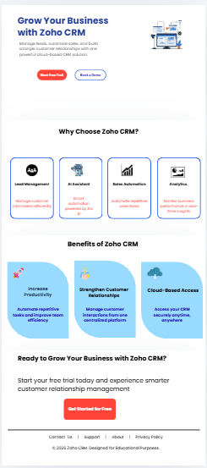
5. Conclusion
This project successfully evaluated the digital presence of Zoho Corporation Pvt. Ltd. through a comprehensive website audit, digital marketing strategy analysis, and the design of a custom landing page. The website audit highlighted Zoho's strengths in website design, user experience, accessibility, and search engine optimization while identifying opportunities to improve overall performance, particularly on mobile devices.
The analysis of Zoho's marketing strategy demonstrated an effective combination of traditional and digital marketing techniques that support customer engagement, lead generation, and brand awareness. Based on these findings, several practical recommendations were proposed to further strengthen the company's digital presence.
A user-focused landing page for Zoho CRM was also designed to promote lead generation through a clear value proposition, well-structured content, and effective call-to-action buttons. Overall, this project demonstrates how website evaluation, digital marketing strategies, and landing page optimization can work together to enhance customer experience and support long-term business growth.

